Exam digital circuits 2022

#### By Jesper Bertelsen, AU-ID: AU689481

1. (10 points) Calculate the following
   1. 1’s and 2’s complements of unsigned (10010011)2

* 1. (10010011)2 – (11010011)2 using 2’s complement (unsigned)

$2^{'}s complement: 10010011=>01101101$

$2^{'}s complement: 11010011=>00101100+1=00101101$

$01101101$

$- 00101101$

=========

$01000000$

=========

Correct let’s check?



$01101101$

$64+32+8+4+1=109$

$- 00101101$

$32+8+4+1=45$

$109-45=64$

===========

$64=01000000$

===========



Check ;)

1. (40 points) in the digital block shown below (Fig1)

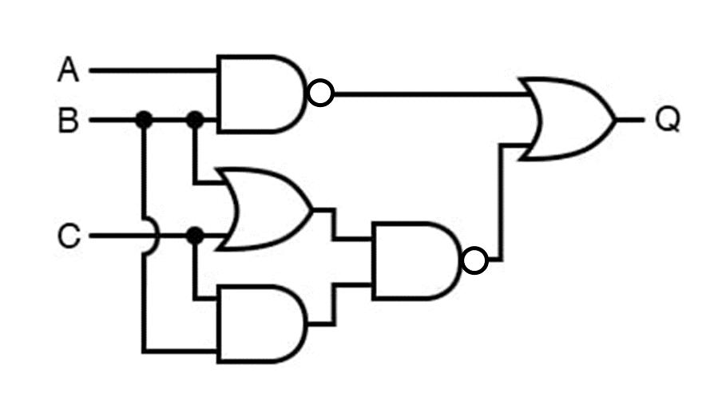

Fig. 1. Logic block

* 1. Find the minterms and maxterms expressions

$f\left(A,B,C\right)=\overline{AB}+\overline{ (B+C)(BC)}$

De Morgan:



* 1. Simplify the circuit using Karnaugh-Map if possible

Observing the karnaugh map we see that function can’t be simplified futher:

* 1. Implement the logic using a Mux

$f\left(A,B,C\right)=\overline{A}+\overline{B}+\overline{C}$

De Morgan:



* 1. Implement the logic using a decoder

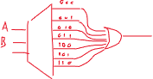

1. (10 points) Design the logic inside the MUX 8x1 block shown in Fig. 2 using only NAND gates.

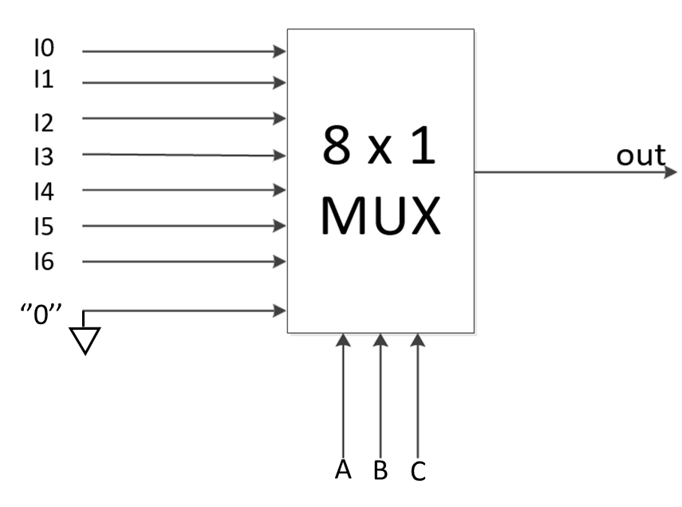

Fig.2. 8×1 Multiplexer

$NAND=\overline{ABC}=\overline{A}+\overline{B}+\overline{C}$

$∑f\left(A,B,C\right)=\left\{0,1,2,3,4,5,6\right\}$

$ABC=7$

$AB\overline{C}=6$

$A\overline{B}C=5$

$A\overline{B}\overline{C}=4$

….

Normal

$I0=\overline{A}\overline{B}\overline{C}$

$I_{1}=\overline{A}\overline{B}C$

$I_{2}=\overline{A}B\overline{C}$

$I_{3}=\overline{A}BC$

$I_{4}=A\overline{B}\overline{C}$

$I_{5}=A\overline{B}C$

$I_{6}=AB\overline{C}$

$I_{7}=ABC$

Good now let’s make the same result but with NAND gates instead of and gates.

$I_{0}=\overline{\left(A+B+C\right)}=\overline{A}\overline{B}\overline{C}$

Let’s now follow the procedure.

$I_{1}=\overline{\left(A+B+\overline{C}\right)}=\overline{A}\overline{B}C$

$I_{2}=\overline{\left(A+\overline{B}+C\right)}=\overline{A}B\overline{C}$

$I_{3}=\overline{\left(A+\overline{B}+\overline{C}\right)}=\overline{A}BC$

$I_{4}=\overline{\left(\overline{A}+B+C\right)}=A\overline{B}\overline{C}$

$I_{5}=\overline{\left(\overline{A}+B+\overline{C}\right)}=A\overline{B}C$

$I_{6}=\overline{\left(\overline{A}+\overline{B}+C\right)}=AB\overline{C}$

$I_{7}=\overline{\left(\overline{A}+\overline{B}+\overline{C}\right)}=ABC$

For simplicity’s sake, let’s say that a gate can take 3 inputs. IRL it would be more like

$\overline{\left(\overline{A}\overline{A}\right)}=A+A$

$\overline{(A)\left(B\right)}=\overline{A}+\overline{B}$

$\overline{\left(\overline{A}+\overline{B}\right)}=AB$

$\overline{\left(\overline{C}+\overline{C}\right)}=CC=C$

$\overline{AB+C}=\overline{A}\overline{B}\overline{C}$

If we were not to simplify it as such it would require 5 NAND gates pr. Output, with the method I derived above.

Instead of using inverters, our system will be using nand gates, to get the same functionality we use:

$\overline{C+C}=\overline{C}$

Now, let’s draw the circuit!

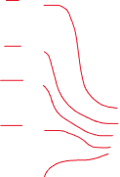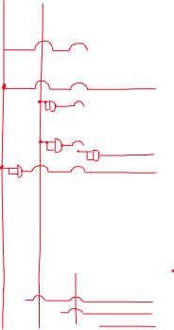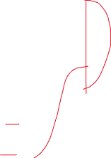

To sum them up we need:

$I_{0}+I_{1}+I_{2}+I_{3}+I_{4}+I_{5}+I_{6}+I_{7}$

$\overline{\overline{I_{0}}\overline{I_{1}}\overline{I_{2}}…}=I_{0}+I_{1}+I_{2}$

For simplicity’s sake we assume that the NAND gate can take 7 inputs. This can happen IRL as well, I derived it for A, B & C, before drawing. This is possible but would require even more work.

1. (40 points) The following expressions describe a sequential circuit, where two flip-flops (One Toggle Flip-Flop and one JK Flip-Flop) triggered with the rising edge of the clock have been used (hint: we have two inputs X and Y which defines the next states and the output).
 $$J_{a}=\overline{X}.B+\overline{Y}.\overline{A}$$

 $$K_{a}=\overline{Y}.B$$

 $$T_{b}=\overline{X}.Y+\overline{Y}.\overline{A}$$

$$Z=\overline{X}.B$$

1. Is this a Mealy or a Moore machine?

We are here getting asked whether our output is dependent on our input(Mealy), or not(Moore).

As our output function Z is depended on our input X, then this machine is a Mealy machine.

* 1. Sketch the logic block diagram of the circuit based on the given information

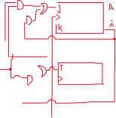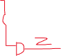

Looking back on it, it’s actually more like a circuit diagram.

Block diagram would look more like this



Know you have both.

* 1. Construct the transition table. Hint: First you need to make the table for JK and D flip flops based on different inputs (XY) and present states from the expressions, then you can make the transition table that includes the present states, next states, and output which are defined based on the inputs and the present states.

Characteristics for our Flip flops taken from the book page, 457.

|  |  |  |  |  |  |  |  |  |  |  |  |  |  |  |
| --- | --- | --- | --- | --- | --- | --- | --- | --- | --- | --- | --- | --- | --- | --- |
| Present state | | |  |  |  |  |  | | |  | Next state |  |  | Output |
| A | B |  |  | X | Y |  | $$J_{A}$$ | $$K_{A}$$ | $$T_{B}$$ |  | A | B |  | Z |
| 0 | 0 |  |  | 0 | 0 |  | 1 | 0 | 1 |  | 1 | 1 |  | 0 |
| 0 | 0 |  |  | 0 | 1 |  | 0 | 0 | 1 |  | 0 | 1 |  | 0 |
| 0 | 0 |  |  | 1 | 0 |  | 1 | 0 | 1 |  | 1 | 1 |  | 0 |
| 0 | 0 |  |  | 1 | 1 |  | 0 | 0 | 0 |  | 0 | 0 |  | 0 |
|  |  |  |  |  |  |  |  |  |  |  |  |  |  |  |
| 0 | 1 |  |  | 0 | 0 |  | 1 | 1 | 1 |  | 1 | 0 |  | 1 |
| 0 | 1 |  |  | 0 | 1 |  | 1 | 0 | 1 |  | 1 | 0 |  | 1 |
| 0 | 1 |  |  | 1 | 0 |  | 1 | 1 | 1 |  | 1 | 0 |  | 0 |
| 0 | 1 |  |  | 1 | 1 |  | 0 | 0 | 0 |  | 0 | 1 |  | 0 |
|  |  |  |  |  |  |  |  |  |  |  |  |  |  |  |
| 1 | 0 |  |  | 0 | 0 |  | 0 | 0 | 0 |  | 1 | 0 |  | 0 |
| 1 | 0 |  |  | 0 | 1 |  | 0 | 0 | 1 |  | 1 | 1 |  | 0 |
| 1 | 0 |  |  | 1 | 0 |  | 0 | 0 | 0 |  | 1 | 0 |  | 0 |
| 1 | 0 |  |  | 1 | 1 |  | 0 | 0 | 0 |  | 1 | 0 |  | 0 |
|  |  |  |  |  |  |  |  |  |  |  |  |  |  |  |
| 1 | 1 |  |  | 0 | 0 |  | 1 | 1 | 0 |  | 0 | 1 |  | 1 |
| 1 | 1 |  |  | 0 | 1 |  | 1 | 0 | 1 |  | 1 | 0 |  | 1 |
| 1 | 1 |  |  | 1 | 0 |  | 0 | 1 | 0 |  | 0 | 1 |  | 0 |
| 1 | 1 |  |  | 1 | 1 |  | 0 | 0 | 0 |  | 1 | 1 |  | 0 |

* 1. Construct the state diagram



Voila!!